**Financial Analytics Report**

**AtliQ Technologies**

**Objective**: To understand the company’s financial performance over the FY 2019-23 and develop profitability and pricing strategies.

**Domain**: Finance

**Tools used**: Excel, Power Query, Pivot tables

1. **Introduction:**

This Financial Analytics Report aims to provide an insight on quarterly and yearly P&L performance for AtliQ company during FY 2019-23. The report highlights key insights and recommendations in setting financial and sales targets. This report can also be used for fact checking and decision-making during business reviews.

**P&L Statement**

* Yearly P&L statement for FY 2019-21
* Quarterly P &L statement for FY 2021
* Market wise P&L statement
* Region wise P&L statement

**Metrics Involved**

* Net Sales
* Cost of goods sold(COGS)
* Gross Margin
* GM % of net Sales

1. **Dataset Overview:**

The data for this analysis was sourced from AtliQ's sales database, covering the period from Sept 1, 2018 to Aug 1, 2021 of almost 800,000 Data points.

The Dataset contain data in 5 csv files:

* **dim_customer** table contains customer data like customer code (PK), customer name, platform, customer channels and the market
* **dim_market** table contains market data like market (PK), subzone and region
* **dim_product** table contains product details like product code (PK), product name, division, segment, category and variant
* **fact_sales_montly** contains net sales details with date, product code, customer code, quantity sold and net sales amount
* **fact_sales_montly with cost** contains data from fact_sales_monthly and in addition contains manufacturing and freight cost.

1. **Data Analysis**

**Step 1-** Extract, Transform and Load (ETL)

* Extract the csv files to Excel sheet
* Transform data
  + Promoting headers
  + Assigning appropriate data types
  + Checking unique values and treating duplicate values
  + Checking and treating null values and errors
  + Trimming spaces
* Loading the data to the data model

**Step 2-** Understanding the data

* Seeking relationship between data tables
* Identifying primary keys in the dimension tables and foreign keys in the fact tables
* Identify relevant data required to prepare performance report
* Identify any new column requirements

**Step 3-** Data Modelling

* Establishing relationships between different data sets using star schema

**Step 4-** Creating dim_date table using Power Query

**Step 5-** Creating user empathetic P&L report.

1. **Results and Conclusions**

**Note:** Refer to the excel file/ PDF reports for more interactive information

* 1. **Year wise P&L Statement:**

During FY 2021, AtliQ generated a gross margin of $218.2 M, reflecting a 2.3% drop compared to the previous FY.

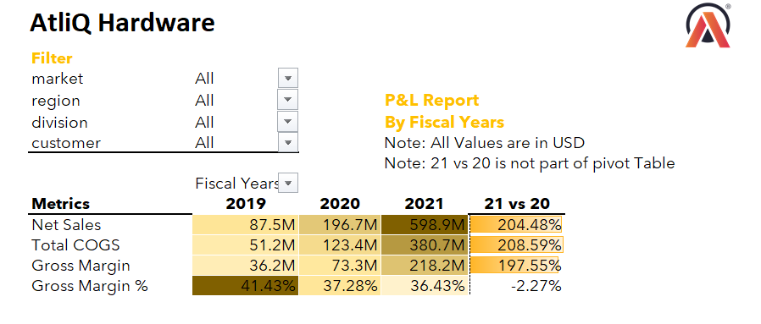

* 1. **Quarterly P&L statement**

During FY 2021, AtliQ has shown a steady GM of around 36 % in all the 4 quarters.

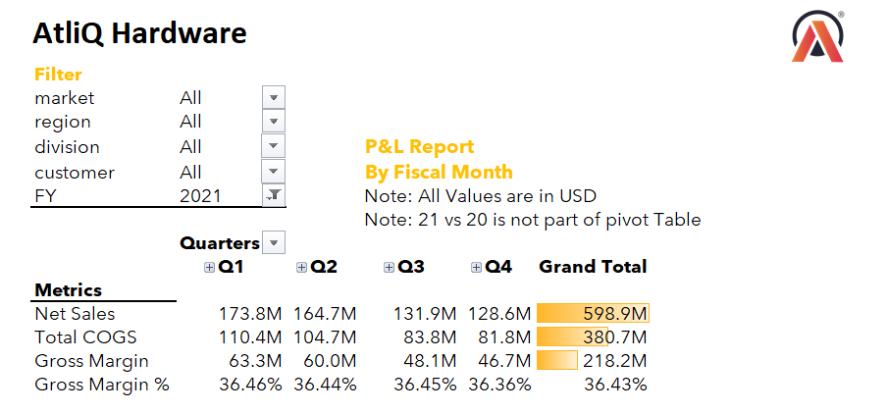

* 1. **Market P&L Report**

During FY 2021, New Zealand market has given the highest GM of 48 % while Germany being at the lowest at 26 %.

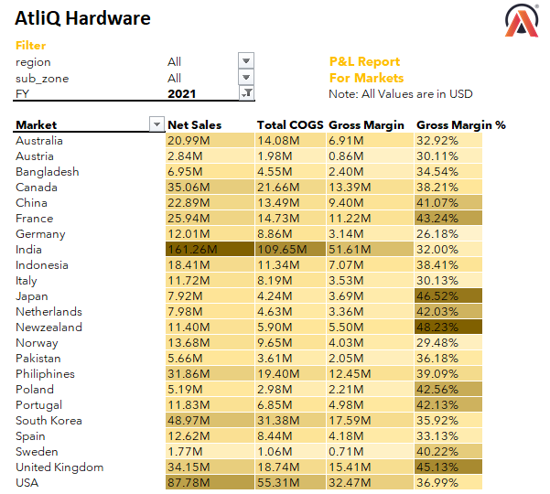

* 1. **Region wise P&L report**

For the FY 2021, all regions have contributed satisfactorily with EU being at the highest with a GM of 38.4 %.

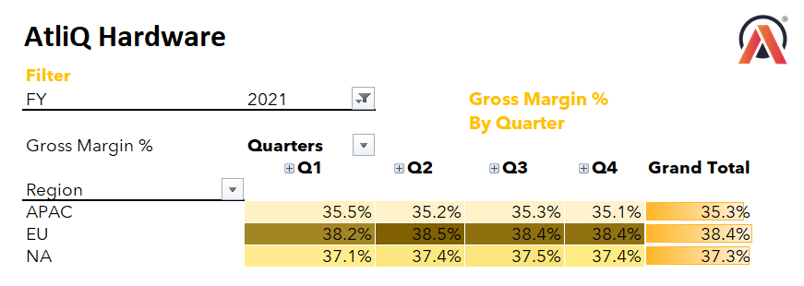

* 1. **Subzone wise P&L report**

During FY 2021, most of the sub zones seems to have a GM of 38 % while India has not shown this pattern and has shown the lowest GM of 32 %.

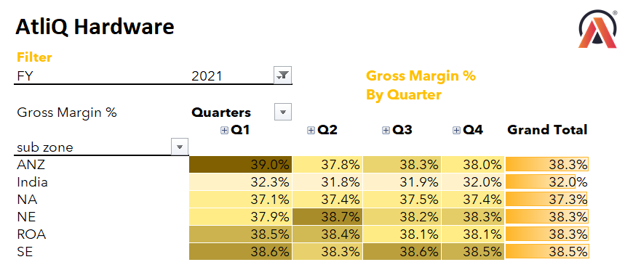

1. **Recommendations:**

AtliQ generated a gross margin of $218.2 M, but reported a 2.3% drop compared to the previous FY, requiring further improvement of sales tactics and marketing strategies.

During the last quarter of the FY 2021, company has seen a shallow drop in the GM although it has been consistent over all the quarters during the entire year. This pattern was also repeated in FY 2020. personalized promotions, customer loyalty programs and discounts can be implemented during the last quarter can give a positive quarter.

APAC region, particularly in Indian subzone has shown the lowest GM %. Region wise marketing initiatives and targeted marketing campaigns may lead to improved sales in that region.